CURRICULAM-VITAE
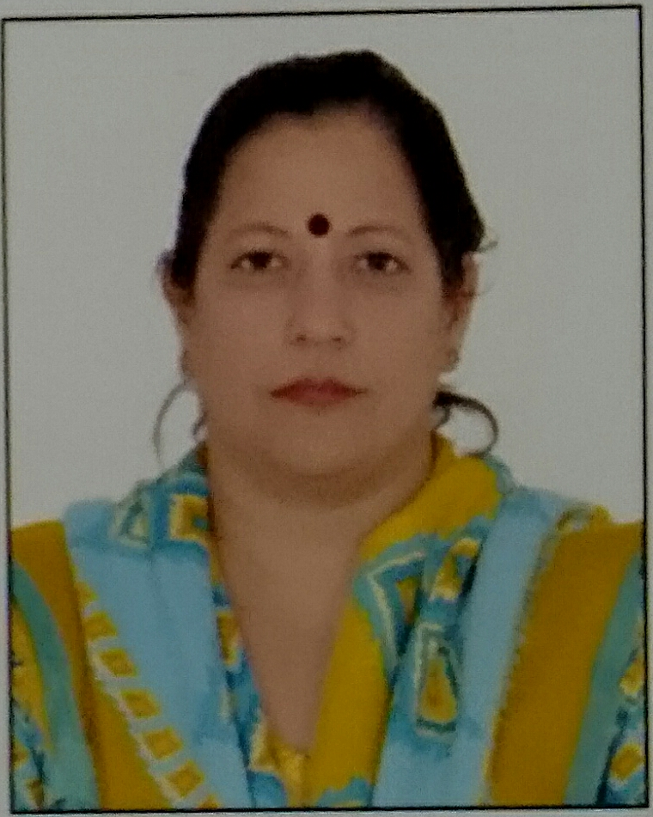

ANITA GIRDHAR
Contact No: 9811058215, 0129-4072975
Address: H.No. 975 Sector 17, Faridabad
E-mail Id: anitagirdhar@jcboseust.ac.in

Career Objective: To seek a job profile that will provide me an opportunity to learn, enrich, grow and enhance my skills, simultaneously contributing to the growth of the organization.

WORK EXPERIENCE:
Working as Assistant Professor (contractual) at J.C.Bose University of Science & Technology, YMCA, Faridabad since 2017.
Earlier worked as Guest Lecturer at Y.M.C.A. Institute of Engineering & Technology from Aug. 2007 to May 2009.

EDUCATIONAL QUALIFICATION

- Ph.D from Manav Rachna International Institute of Research and Studies,
Title: Exploration and Assessment of Efficiency of Azolla microphylla biomass for Removal of heavy Metals Lead and Cadmium from Wastewater.
- Cleared UGC-NET in June 2010.
- Diploma in Industrial Pollution and Control from Annamalai University in 1995 with 78.5 %.
- M.Sc in Bioscience with specialization in Environmental Biology from M.D.U. Rohtak in 1993 with 68.33%.
- B. Sc. Zoology Hons. from Gargi College , Delhi University, in 1991 with 62.6%.
- Senior Secondary from A.P.J. School, Sec-15, Faridabad in 1988 with 77.6 aggregate and 86% PCB.
- Higher Secondary from St. Joseph’s Convent School, N.I.T. 5, Faridabad in 1986 with 71.6%.

PAPERS PRESENTED IN CONFERENCES/WORKSHOPS:
CONFERENCES:
- Presented a paper a paper titled “ Bioremediation potential of Azolla microphylla biomass to remove heavy metal lead and cadmium from wastewater” in an International conference on “ Environmental Challenges and Solutions” held from 31Jan-2Feb,2020 organised by Manav Rachna International Institute of Research and Studies”, Faridabad.
- Presented a paper titled “Biosorption studies on Azolla microphylla biomass for Cadmium removal from aqueous solutions.”in a National conference on “Emerging Trends In Engineering Science And Technology (ICETESI-2018) held on Feb.16-17,2018 organised by Maharishi Markendeshwar Engineering College, Mullana, Ambala.
- Presented a paper titled “Physico –Chemical Assessment of water of Buria Nallah”in a National conference on “New Horizons in Technology for Sustainable Energy and Environment”(NHTSEE-2017) held on March9-10,2017 organised by YMCA University of Science and Technology, Faridabad.

- Presented a paper titled “Use of Azolla microphylla plant as a new approach for cleaning industrial waste water in one day National Workshop on “Role of Groundwater in Smart Cities & Villages” organized by Centre for Advanced Water Technology & Management, Manav Rachna International University, Indian National Committee of International Association of Hydrogeologists and Municipal Corporation Faridabad on 17 December,2016.

- Presented a paper titled “Evaluating Growth Responses of Azolla microphylla to heavy metal Cadmium exposure” and awarded “Best presenter award” in a National conference on “Emerging Trends And Technologies in Sciences”(NCETTS-2016) held on March 25-26,2016 at Aggarwal College, Ballabgarh.

- Presented a paper titled “Assessment of Wastewater of Buria Nallah in one day National Workshop on “Water conservation & Pollution” organized by Manav Rachna International University and Indian National Committee of International Association of Hydrogeologists on 19 December,2015.

- Presented a paper titled“Assessing The Phytoremediation Potential And The Metabolic Responses Of Azolla Microphylla On Lead Exposure” and awarded “Best paper award in Environmental Science” in a National conference on “Recent Advances in Applied Sciences and Humanities”(NCASH-2015) held on October 10,2015 at Rawal Institute of Engineering and Technology”, Faridabad.

- Participated and Presented paper in an International Conference on Green Initiatives in Science and Technology titled “Azolla: A green option for Cadmium removal from wastewaters, organized by Department of Chemistry, Manav Rachna College of Engineering, Faridabad ,on January 15,2015.

- Presented a paper titled”Study Of Effect Of Lead And Cadmium On Azolla Microphylla Biomass To Assess Its Potential For Bioremediation” in Asian Congress on Biotechnology 2013, an International conference organized by IIT-Delhi under the Aegis of Asian Federation of Biotechnology, held from Dec.15-19 ,2013, at New Delhi.

- Presented a paper titled “Utilization of Azolla microphylla biomass for removal of heavy metals cadmium (Cd) and lead (Pb) from water” in National conference on “Biomass Utilization” organized by Institute of Engineers India Limited on 17th-18th May 2013 at Manav Rachna International University.

- Participated in two day National Conference on “Science in Media” held on 3rd-4th December 2012, at YMCA University of Science and Technology, Faridabad. Presented a paper titled “Azolla: Role in Phytoremediation”.

- Participated in International Symposium on “Recent advances in green chemistry and chromatography sciences”, organized by Indian Society of Analytical Scientist (Delhi chapter) at Manav Rachna International University from 12th-14th January 2012. Presented a paper titled “Biosorption potential of Azolla microphylla biomass for removal of heavy metals Cadmium and Lead from waste water, Abstract published in proceedings of the conference.

- Participated in National conference on Ethics, Values & Morality: Concept, Theory & Practice on 28th May 2011, organized by Department of Humanities and Management,FET, MRIU, Faridabad.

WORKSHOPS:
- Participated in two day Research Workshop on SPSS-Based Application of Statistical Techniques in Doctoral Research on September 20th and 27th 2014 organised by Centre For Continuing Education MRIU, Faridabad.

- Participated in International Workshop on Biofuel 2012 organized by Department of Biotechnology, Faculty of Engineering & Technology, Manav Rachna International University, Faridabad, on November 5, 2012.

- Attended a workshop on Chromatography on 11th January 2012 organized by Indian Society of Analytical Scientist (Delhi chapter) and Manav Rachna International University at MRIU, Faridabad, Haryana.

- Participated in the Workshop on “Intellectual Property Right(IPR): Oppurtunities and Strategies”, organized by Department of Biotechnology, FET, MRIU, Faridabad on September 1, 2012.

- Participated in Workshop on Innovative Technologies for Water Detoxification held on January 14-15, 2013 organized by Department of Chemistry Manav Rachna College of Engineering, Faridabad.

JOURNAL PUBLICATIONS:
- Published a paper in International Journal of Scientific Research (ISSN:2277-8179), Volume4, Issue 10, October 2015 Edition titled” Assessing The Phytoremediation Potential And The Metabolic Responses Of Azolla Microphylla On Lead Exposure”.
- Published a paper in International Journal of Scientific & Engineering Research (ISSN:2229-5518), Volume6, Issue 9, September 2015 Edition titled”Cadmium Toxicity and Its Phytoremediation- A Review”.
- Paper titled ”Azolla: Role in Phytoremediation” was published in International Journal of Engineering Sciences (ISSN [Online]:2277-9698, December 2012.

FDP/OTHERS:
- Participated in 5 day FDP on “Research Methods and Data Analysis Tools in Business Applications” organized by Department of Management studies, JC Bose University of Science & Technology, Faridabad, from 2^{4th} Sep.2019 to 2^{8th} Sep.2019.
- Participated in 7 day FDP on “Innovative Teaching Methodologies in Technical Education” organized by Department of Management studies, JC Bose University of Science & Technology, Faridabad, from 29th April, 2019 to 4th May,2019.
- Participated in 6 day FDP on “Climate change & Sustainable Infrastructure development( NITTR Chandigarh sponsored)” organized by Department of Humanities and Sciences, JC Bose University of Science & Technology, Faridabad, from 4th- 9th June 2018.
- Participated in Faculty Development Programme, Workshop on Bioinformatics Tools and Computational Biology on 17th Dec. 2011 organized by Department of Biotechnology, FET, MRIU, Faridabad, Haryana.

AWARDS AND ACHIEVEMENTS:
- House captain in A.P.J. School, Sec-15, Faridabad in the year 1986-87.
- Represented district Basketball and Handball team twice in the year, 1986 and 1987 at State level tournaments.
- Awarded Sports Championship in St. Joseph’s Convent School in the year 1983.

PERSONALITY TRAITS

Confident, Self motivated, zest for achieving perfection in my job.

POTENTIALS

High level of Adaptability, Hard working, Sincerity & Punctuality.

HOBBIES

- Reading
- Listening music.

PERSONAL DETAILS

Husband’s Name : Mr. Atul Girdhar

Date of Birth : 03.02.1971

Sex : Female

Marital Status : Married

Nationality : Indian

Languages Known : English, Hindi and Punjabi

PLACE: FARIDABAD
(Anita Girdhar)

